Doubly linked list
Made my shah fahad
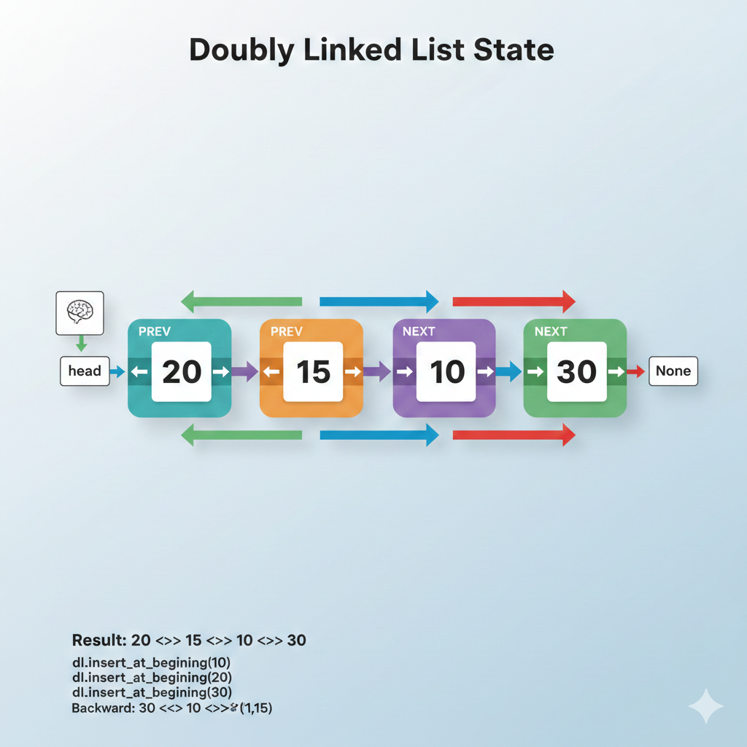
What is a Linked List?
A Linked List is a linear data structure where elements, called nodes, are not stored in a single block of memory like an array. Instead, they are scattered throughout memory and "linked" together using pointers.
+1
Each node consists of two parts:
- Data: The actual information you want to store (like a number or string).
- Next Pointer: A reference (address) that points to the location of the next node in the sequence.
The list begins with a Head (the first node) and ends with a Tail that points to Null (indicating the end of the chain).
Why Do We Use It?
We use linked lists because they offer flexibility that standard arrays do not. Here are the primary reasons:
1. Dynamic Size
Unlike arrays, which usually require you to define a fixed size upfront, linked lists can grow or shrink at runtime. You only use the memory you need, and you never have to "resize" the list or copy it to a new memory location.
2. Efficient Insertions and Deletions
In an array, if you want to add an item to the middle, you have to shift every single item after it to the right. In a linked list, you just "snip" the connection and point it to the new node.
- Array Insertion: $O(n)$ (Slow for large lists)
- Linked List Insertion: O(1) (Very fast, provided you are already at the insertion point)
3. No Memory Fragmentation Issues
Because nodes are stored wherever there is free space in memory, linked lists can function even if your computer’s memory is "fragmented" (broken into small pieces). An array requires one large, continuous block of memory, which might not always be available
Music Playlists: Each song points to the next song. You can easily add or remove tracks without shifting the whole list.
Web Browser History: A "Back" and "Forward" button uses a Doubly Linked List to let you move between pages.
Undo/Redo Functionality: Each action is a node; hitting "Undo" simply moves the pointer back to the previous state.
Here is the line-by-line explanation of your code.
The Node Class
This class creates the individual "links" for the chain.
- class Node:: Defines the blueprint for a single element in the list.
- def __init__(self, prev=None, data=None, next=None):: The constructor that runs when a node is created.
- self.prev=prev: Stores a pointer to the node before this one.
- self.data=data: Stores the actual value (like 10 or 20).
- self.next=next: Stores a pointer to the node after this one.
The Doubly Linked List Class
This class manages the nodes and the connections between them.
- def __init__(self):: Initializes an empty list.
- self.head=None: Initially, there is no first node, so the head is empty.
insert_at_begining
- if self.head is None:: Checks if the list is currently empty.
- node=Node(None,data,None): If empty, create a node with no neighbors.
- self.head=node: Set this new node as the starting point.
- node=Node(None, data, self.head): If not empty, create a new node whose next points to the current head.
- self.head=node: Update the list's head to be this new node.
insert_at_end
- if self.head == None:: If the list is empty, just use the "beginning" function.
- itr = self.head: Start a "pointer" (iterator) at the beginning.
- while itr.next:: Keep moving the pointer until you find the node where there is nothing after it.
- node=Node(itr,data,None): Create a new node. Its prev is the current last node (itr).
- itr.next=node: Link the old last node's next to this new node.
leng_of_list
- count=0: Start a counter at zero.
- while itr:: Move through every single node until you hit None.
- count += 1: Add 1 for every node you step on.
insert_at
- if index == 0:: If the user wants the start, call the insert_at_begining function.
- if index <0 or index > self.leng_of_list():: Safety check to ensure the index exists.
- while itr:: Loop through the list to find the spot.
- if count == index - 1:: Stop at the node just before where you want to insert.
- node=Node(itr, data, itr.next): Create the new node and link it to its neighbors.
- if node.next: node.next.prev=node: If there is a node after our new one, tell it to point its prev back to our new node.
- itr.next=node: Tell the previous node to point its next to our new node.
print_backward
- while itr.next:: First, walk all the way to the very last node.
- while itr:: Now, walk backwards using the prev pointers.
- back += str(itr.data) + ("<-->"if itr.prev else ""): Build a string of the data as you move backwards.
print_
- while itr:: Move forward from the head.
- dlls += str(itr.data) + (" <--> " if itr.next else ""): Build a string showing the list from start to finish.
The Execution Block (if __name__ == "__main__":)
This is where you actually run the commands to build the list shown in the diagram.
- dl.insert_at_begining(10): List is 10.
- dl.insert_at_begining(20): List is 20 <--> 10.
- dl.insert_at_end(30): List is 20 <--> 10 <--> 30.
- dl.insert_at(1,15): Squeezes 15 at index 1. List is 20 <--> 15 <--> 10 <--> 30.
Code:
class Node:
def __init__(self, prev=None, data=None, next=None):
self.prev=prev
self.data=data
self.next=next

class doubly_linked_list:
def __init__(self):
self.head=None
def insert_at_begining(self,data):
if self.head is None:
node=Node(None,data,None)
self.head=node
return
node=Node(None, data, self.head)
self.head=node
return
def insert_at_end(self,data):
if self.head == None:
self.insert_at_begining(data)
return
itr = self.head
while itr.next:
itr=itr.next
node=Node(itr,data,None)
itr.next=node
def leng_of_list(self):
count=0
itr=self.head
while itr:
count += 1
itr = itr.next
return count
def insert_at(self, index, data):
if index == 0:
self.insert_at_begining(data)
if index <0 or index > self.leng_of_list():
raise Exception ("Index out of range")

count=0
itr=self.head
while itr:
if count == index -1:
node=Node(itr, data, itr.next )
if node.next:
node.next.prev=node
itr.next=node
itr=itr.next
count+=1
def print_backward(self):
if self.head == None:
raise Exception("double linked list is empty")
itr=self.head
while itr.next:
itr=itr.next
back=''
while itr:
back += str(itr.data) + ("<-->"if itr.prev else "")
itr=itr.prev
print("Backward", back)

def print_(self):
if self.head == None:
raise Exception("double linked list is empty")
itr=self.head
dlls=''
while itr:
dlls += str(itr.data) + (" <--> " if itr.next else "")
itr=itr.next

print(dlls)

if __name__ == "__main__":
dl=doubly_linked_list()
dl.insert_at_begining(10)
dl.insert_at_begining(20)
dl.insert_at_end(30)
dl.insert_at(1,15)
dl.print_backward()
dl.print_()

